**PUBLIC TRANSPORT EFFICIENCY ANALYSIS**

**PHASE II**

**NAME: SARASWATHI G**

**REGISTRATION NO: 412621243043**

**Enhancing Public Transportation with Predictive Maintenance in ML and Passenger Sentiment Analysis**

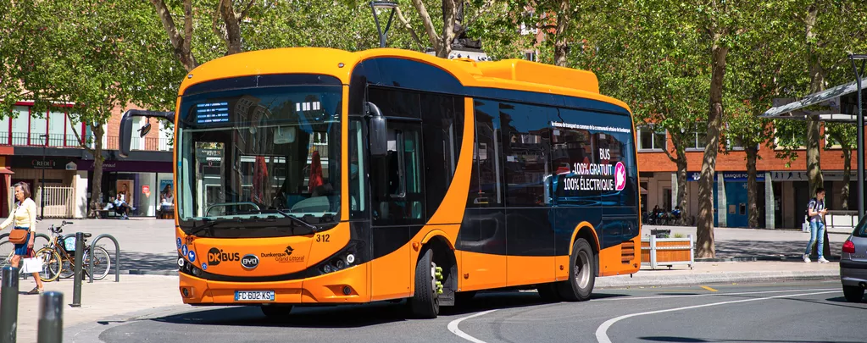

**Project Overview:**

The project involves analyzing public transportation data to assess service efficiency, on time performance, and passenger feedback. The objective is to provide insights that support transportation improvement initiatives and enhance the overall public transportation experience. This project includes defining analysis objectives, collecting transportation data, designing relevant visualizations in IBM Cognos, and using code for data analysis.

**DESIGN THINKING:**

**Phase 1: Data Collection and Preparation**

**Step 1: Data Collection**

- Identify relevant data sources:

- Historical transportation service data (e.g., schedules, routes, delays)

- IoT sensor data from vehicles (e.g., engine performance, maintenance logs)

- Passenger feedback and sentiment data (e.g., surveys, social media)

- Establish data sharing agreements with relevant authorities and transportation companies.

**Step 2: Data Cleaning and Integration**

- Clean and preprocess data to handle missing values, outliers, and inconsistencies.

- Integrate data from various sources into a centralized data repository.

**Phase 2: Machine Learning Model Development**

**Step 3: Feature Engineering**

- Define relevant features for predicting service disruptions and analyzing sentiment.

- Create feature vectors that represent historical patterns and passenger feedback.

**Step 4: Predictive Maintenance Model**

- Develop a machine learning model (e.g., regression, classification) to predict service disruptions based on historical data and vehicle sensor data.

- Implement anomaly detection algorithms to identify potential maintenance issues.

**Step 5: Sentiment Analysis Model**

- Train an NLP model (e.g., LSTM, BERT) to analyze passenger sentiment from feedback data.

- Perform sentiment classification (positive, negative, neutral) and topic extraction.

**Step 6: Model Validation and Optimization**

- Split data into training, validation, and testing sets.

- Fine-tune models and optimize hyperparameters to maximize accuracy and performance.

**Phase 3: Integration and Deployment**

**Step 7: Integration with Transportation Systems**

- Develop APIs to integrate predictive maintenance and sentiment analysis models with the transportation infrastructure.

- Ensure real-time data flow from vehicles and passenger feedback channels to the models.

**Step 8: Dashboard Development**

- Create a user-friendly dashboard for transportation operators and managers.

- Display real-time service disruption predictions and sentiment analysis results.

**Phase 4: Testing and Evaluation**

**Step 9: Pilot Testing**

- Conduct a pilot test of the integrated system on a small scale.

- Collect feedback from transportation staff and passengers for further refinement.

**Step 10: Performance Evaluation**

- Evaluate the accuracy of service disruption predictions and sentiment analysis.

- Measure the impact on service reliability and passenger satisfaction.

**Phase 5: Scaling and Continuous Improvement**

**Step 11: Full-Scale Deployment**

- Deploy the integrated system across the entire public transportation network.

- Monitor system performance and scalability.

**Step 12: Continuous Improvement**

- Implement feedback loops for model retraining and refinement.

- Stay updated with evolving machine learning and NLP techniques.

**Phase 6: Maintenance and Support**

**Step 13: Maintenance**

- Provide ongoing maintenance and support for the deployed system.

- Address any issues, bugs, or performance issues promptly.

**Step 14: User Training and Documentation**

- Train transportation personnel in using the system effectively.

- Maintain comprehensive documentation for reference.

**Conclusion:**

In this document outlines the complete steps for transforming the initial design idea into a practical solution for improving public transportation through predictive maintenance and passenger sentiment analysis. Each phase involves critical tasks that contribute to the success of the project. Continuous monitoring, feedback, and improvement are essential to ensure the system's long-term effectiveness and reliability. This plan has high-level overview, and the actual implementation may require further detail and customization based on specific transportation systems, technologies, and data sources.